1.When to use (Rapid Application Development) RAD model When not to use (Rapid Application Development) RAD model
soln: RAD model can be applied successfully to the projects in which clear modularization is possible. If the project cannot be broken into modules, RAD may fail. Following are the typical scenarios where RAD can be used:
- RAD should be used only when a system can be modularized to be delivered in incremental manner.
- It should be used if there.s high availability of designers for modeling.
- It should be used only if the budget permits use of automated code generating tools.
- RAD SDLC model should be chosen only if domain experts are available with relevant business knowledge.
- Should be used where the requirements change during the course of the project and working prototypes are to be presented to customer in small iterations of 2-3 months.
There are also scenarios where we cannot implement the RAD model. They are:
- if highly skilled developers or designers are not available
- if the project is to be made cheap ie, if the budget is low RAD should not be implemented
- if the development time is large
- if the project cannot be modularized
- if there are no technically strong team members for identifying business requirements

2.Define an ER diagram of a software Organization with all the relationship model that was discussed in the classroom
soln:

here m m represents many to many

m 1 represents many to 1

1 1 represents 1 to 1

abc represents primary key

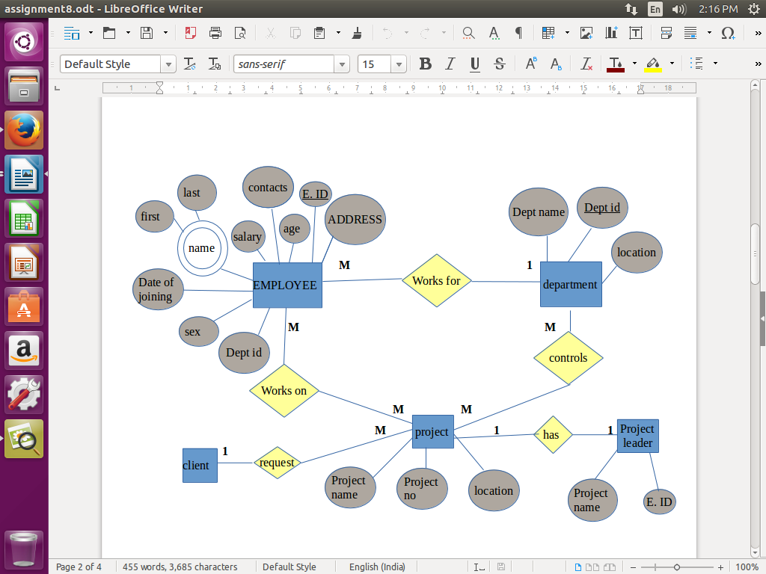

3.Describe the Entity Relationships for the following diagram

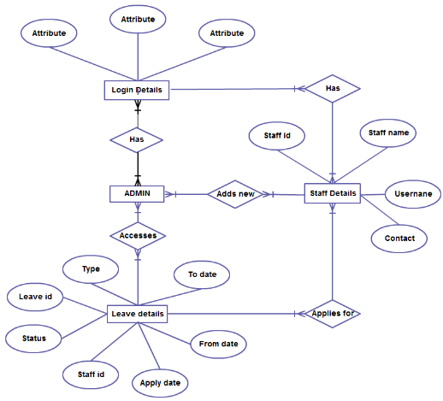

here
- The entities are
1. Login Details
2. Admin
3. Leave details
4. Staff details
- There are Three Attributes for Login details
- Leave details has 7 attributes: Type, Leave id, Status, Staff id, Apply date, From date, To date
- Staff details has 4 attributes: Staff id, Staff name, Username, Contact
relationships are as follows:
- One user login has many staff details and one staff has many login details.Hence the cardinality between login details and staff details is Many to Many (M:N)

- One login has many admins and one admin has many login details.Hence the cardinality between login details and admin is Many to Many (M:N)

- One admin can access many leave details and one leave details can be accesed by many admins details.Hence the cardinality between leave details and admin is Many to Many (M:N)

- one staff can applay for many leave details and one leave details can be accesed by many staffs. Hence the cardinality between Staff details and Admin is Many to Many (M:N)

